Experiment 7
Name : Padma Priya D Roll No : 240701377
Experiment with different layouts and colour schemes for an app. Collect user feedback on aesthetics and usability.
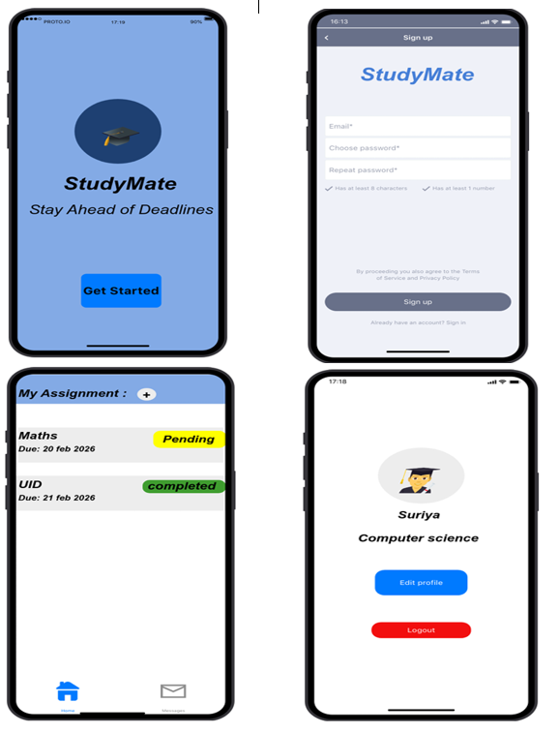
App Name:
StudyMate (Student Productivity App UI Design)

Light Mode Design (Blue Theme)

Description
Light mode is a user interface design where:
- Background is light (white / light blue)
- Text is dark for better readability

Characteristics
- Easy to read in daylight
- Clean and simple interface
- User-friendly for long usage
- Common default design

Screens Designed
- Splash Screen
- Login Screen
- Dashboard Screen
- Profile Screen

Design Details
- Background Colour: Light Blue
- Text Colour: Black / Dark Blue
- Buttons: Blue
- Theme Feel: Clean, simple, and professional

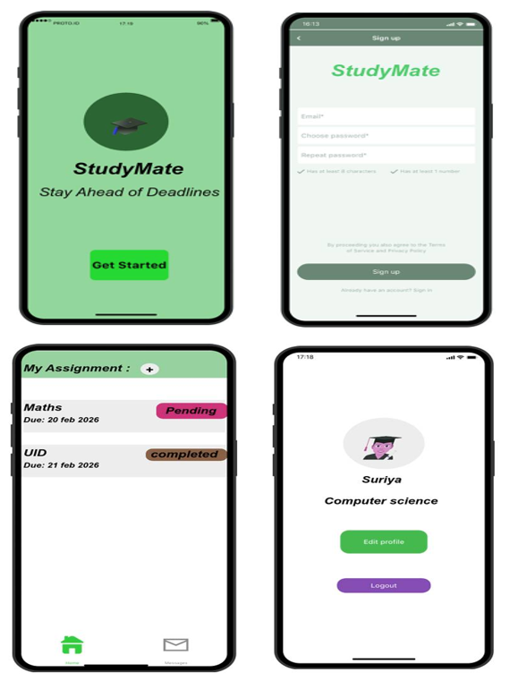
Green Theme Design

Description
Green theme provides a natural and refreshing user interface design.

Characteristics
- Calm and pleasant appearance
- Reduces eye strain
- Gives fresh and modern look

Screens Designed
- Splash Screen
- Login Screen
- Dashboard Screen
- Profile Screen

Design Details
- Background Colour: Light Green
- Text Colour: Black
- Buttons: Green / Purple
- Theme Feel: Refreshing and attractive

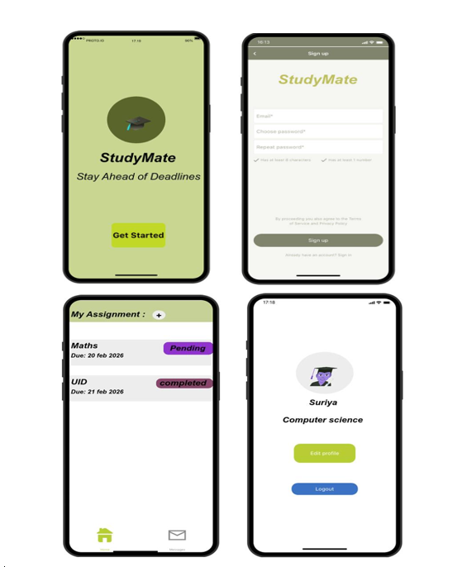
Beige Theme Design

Description
Sandal theme is a soft and warm color scheme that provides a smooth user experience.

Characteristics
- Soft and comfortable to view
- Less strain on eyes
- Elegant and unique appearance
- Suitable for long usage

Screens Designed
- Splash Screen
- Login Screen
- Dashboard Screen
- Profile Screen

Design Details
- Background Colour: Sandal / Beige
- Text Colour: Dark Brown / Black
- Buttons: Light Green / Blue
- Theme Feel: Warm, smooth, and elegant
A Google Form was created and shared with users to collect feedback about:
- Design appearance
- Colour preference
- Ease of use
- Suggestions for improvement
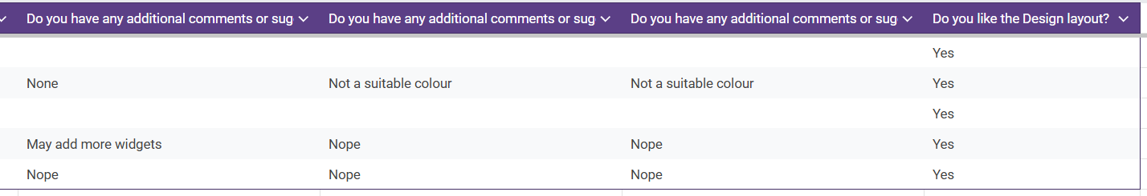
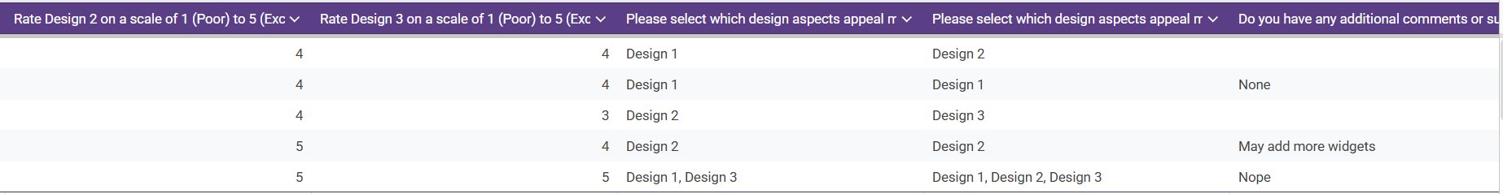
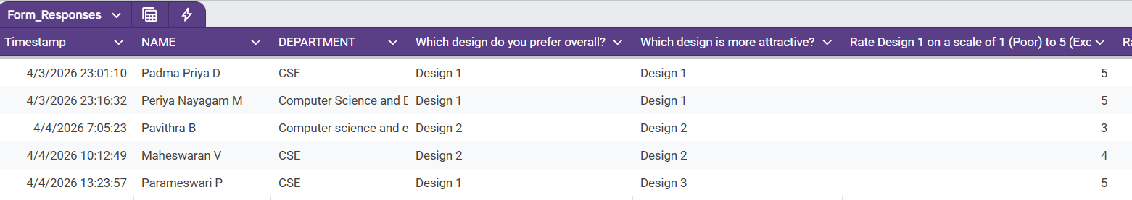
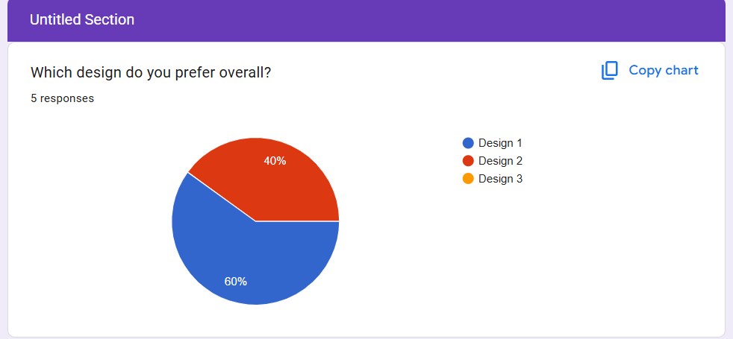
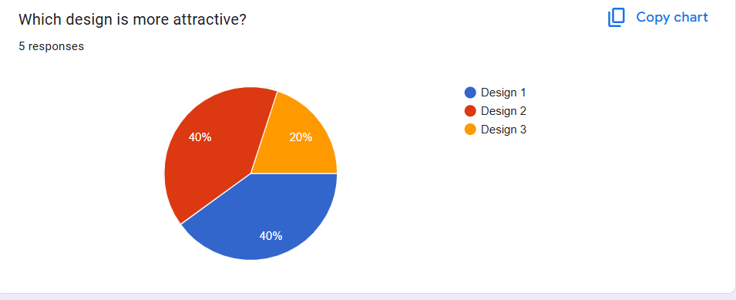
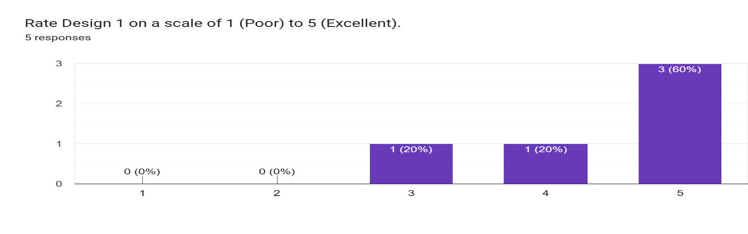
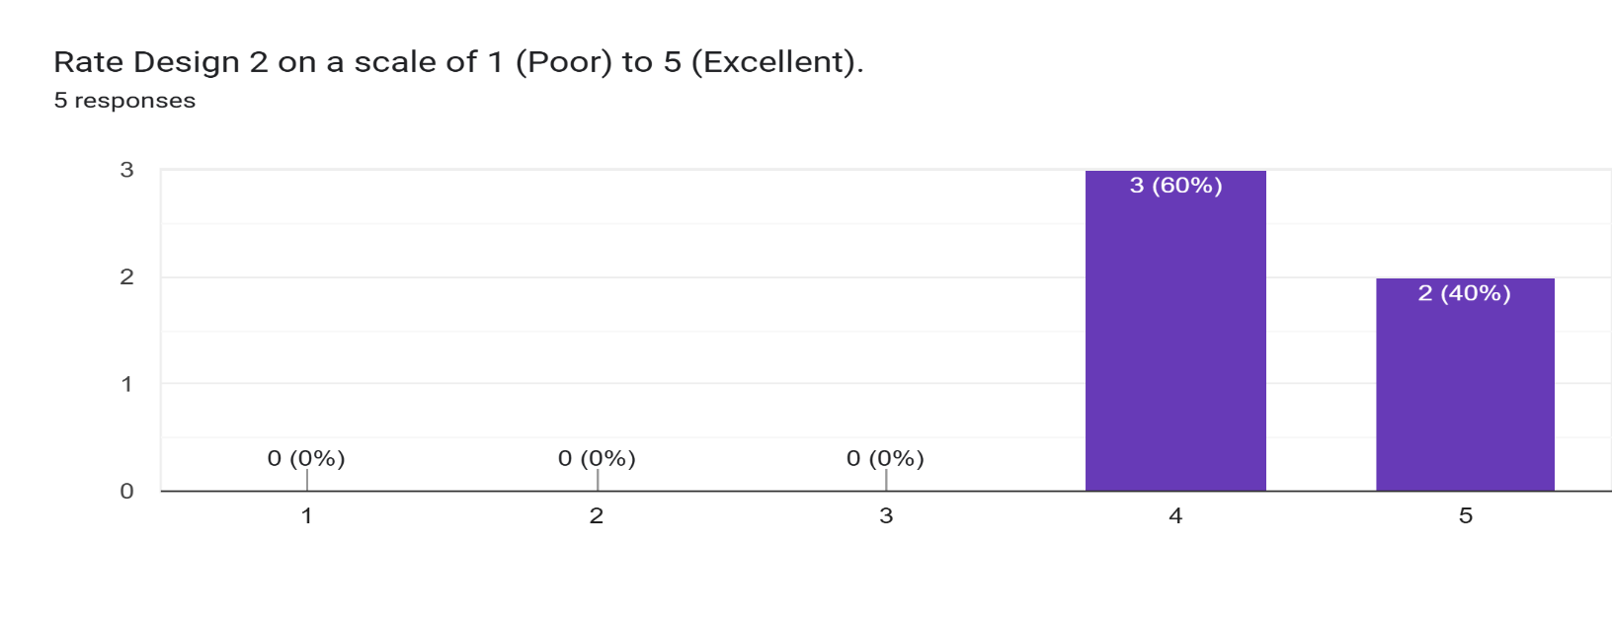

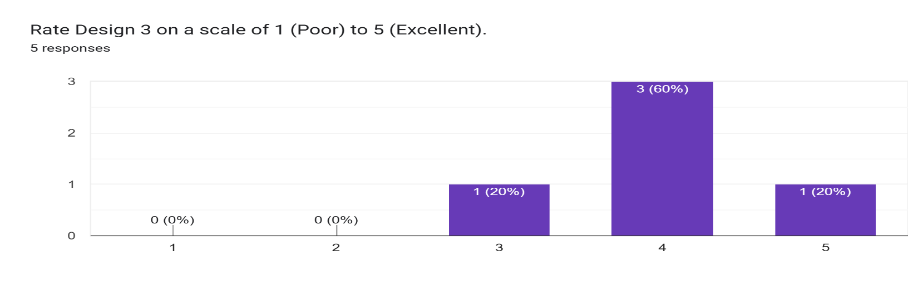
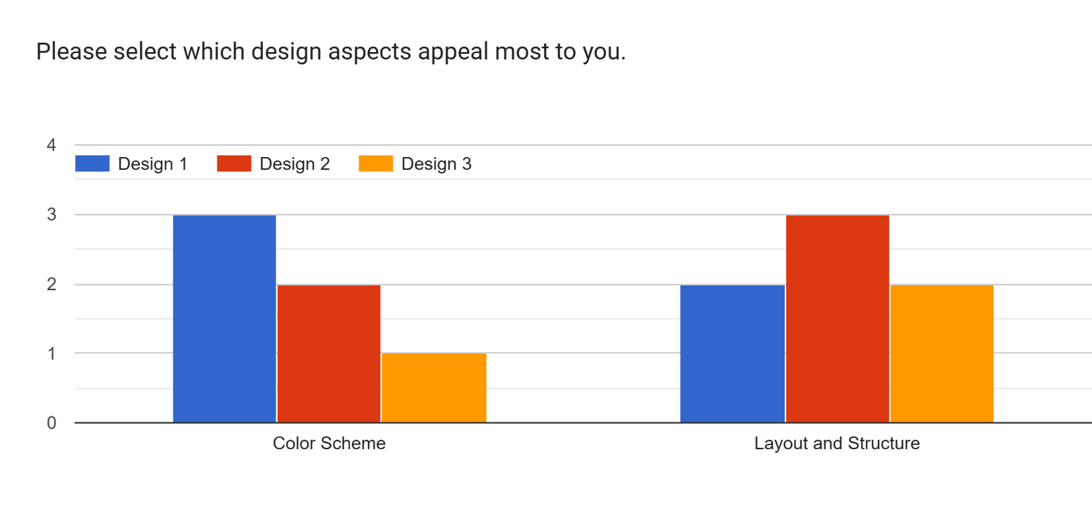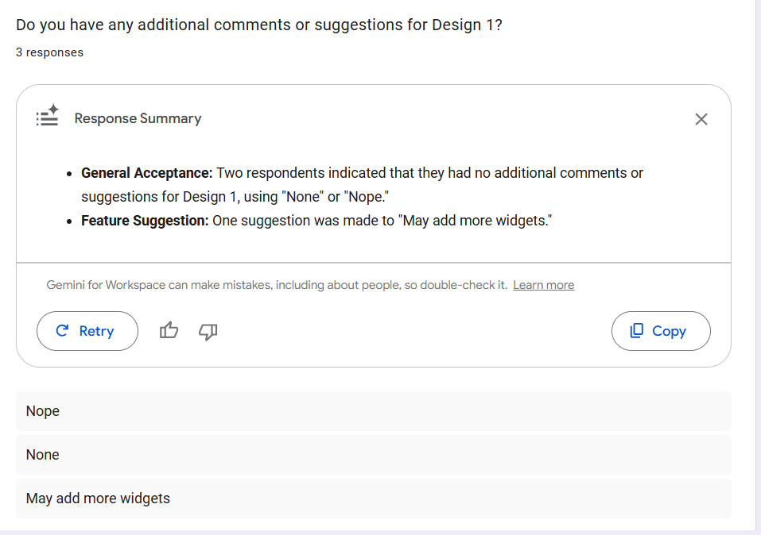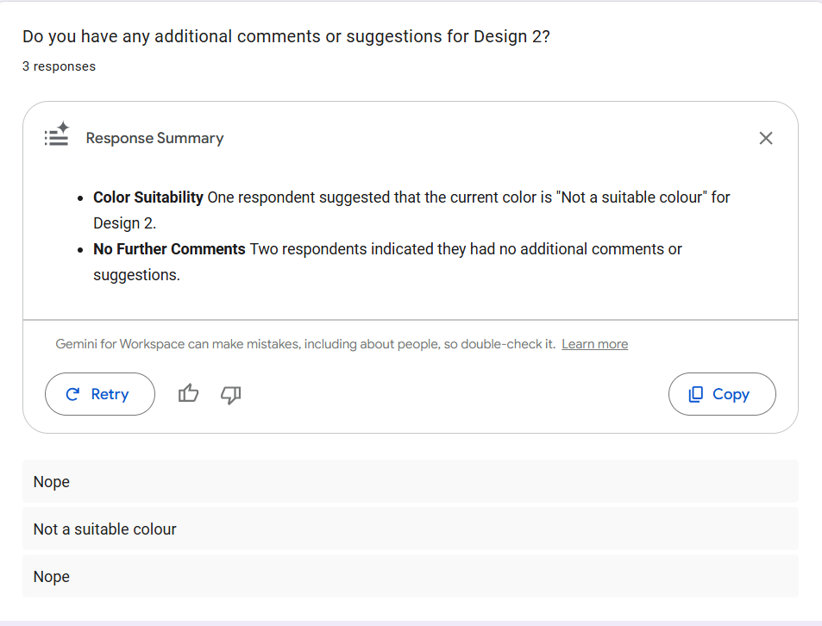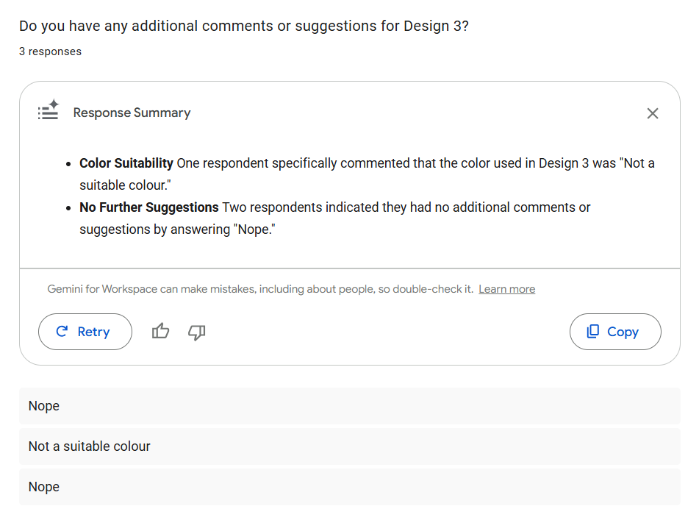
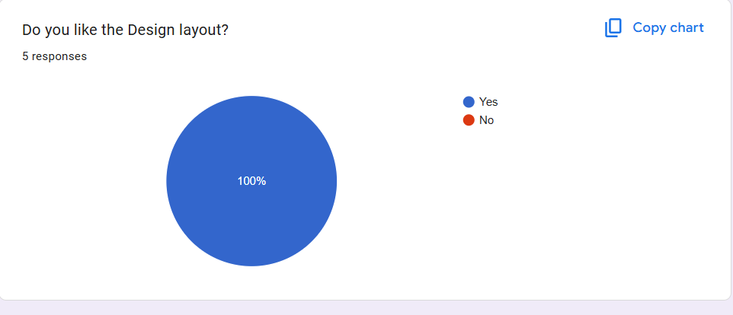
Inference
- Light mode is more popular among users
- The app design is visually appealing and user-friendly
- Minor improvements can be made in readability and spacing
- Overall, the UI design was successful and well-received

